
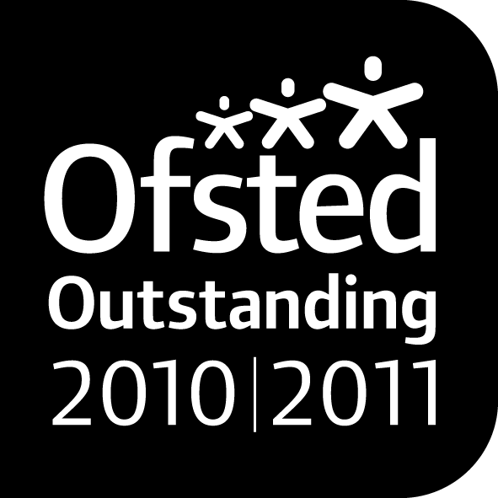
PRE-SCHOOL JOB VACANCIES
To start as soon as possible

Permanent Full Time Key Person

33^{1/2} hours per week 8.45am-4.00pm and Tuesday 8.45am-4.45pm
Term time only Up to £8.20 per hour
Applicants must hold a minimum of
Level 3 Qualification in Childcare and Education or equivalent
or be working towards Level 3 (with experience)

Permanent Pre-School Assistant

10 Hours per week
11:15am-1:15pm Monday to Friday
with the opportunity for more hours to cover staff sickness or training
Term time only Up to £7.20 per hour
Applicants must hold a minimum of
Level 2 Qualification in Childcare and Education or equivalent or be working towards Level 2 (with experience)

Return of applications:
3rd July 2015
Please ask within for an application pack or contact us using the number below or email address the application is also available to download

